**Sauce & Spoon Project Team**

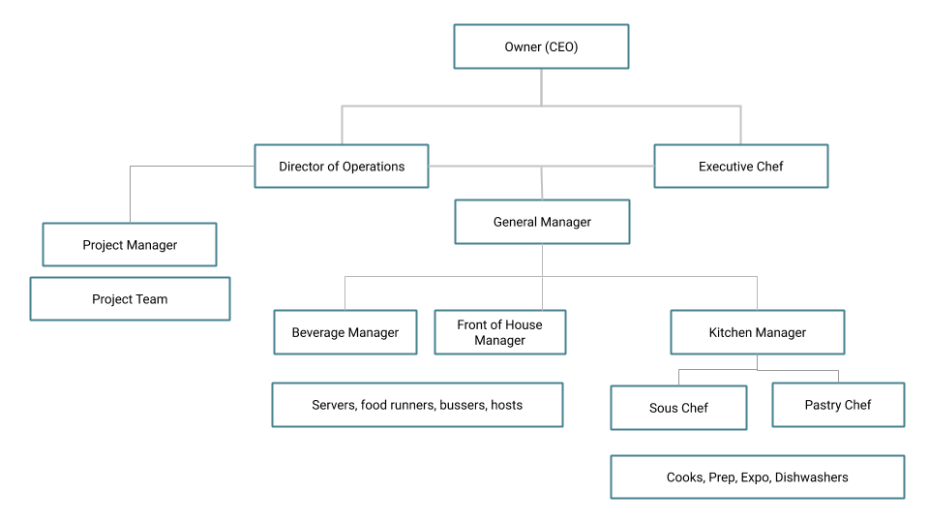

**Omar Mubarak, CEO: Keep Satisfied**

Omar is the owner and CEO of Sauce & Spoon, overseeing its direction, profitability, and reputation. He supports initiatives that advance the restaurant’s mission and vision.

**Deanna Coleman, Director of Operations: Monitor closely**

Deanna, with a background in hedge fund management, leads Sauce & Spoon’s initiatives and ensures ingredient integrity. She oversees restaurant managers and handles hiring and training.

**Carter Ward, Executive Chef:** **Keep Satisfied**

Carter, a former military chef, is the visionary behind Sauce & Spoon’s sustainable and scratch-to-table cuisine. He oversees all menu choices and kitchen staff.

**Gilly Tyson, General Manager (North): Monitor Closely**

Gilly manages the business district location, handling staff hiring, training, and supply orders. She ensures customer satisfaction and is a respected resource for training.

**Alex Schmidt, General Manager (Downtown):** **Manage Closely**

Alex, new to the role from retail management, manages the downtown location. They handle staff hiring, training, supply orders, and customer satisfaction, benefiting from Gilly’s training.

**Nia Williams, General Manager (Waterfront): Monitor**

Nia started as a hostess in high school and worked her way up to management. Before joining Sauce & Spoon, she tended bar at a luxury hotel. She hires and trains staff, orders supplies, and ensures customer satisfaction at the Waterfront location.

**Zane Dutchman, Kitchen Manager (North): Show consideration**

 Formerly a sous chef, Zane is learning the ropes as kitchen manager, with guidance from Larissa. They oversee back-of-house operations, control costs, and manage labor at the North location.

**Larissa Stein, Kitchen Manager (Downtown):** **Show Consideration**

New to Sauce & Spoon, Larissa previously managed a Michelin-star kitchen in NYC. She oversees back-of-house operations, controls costs, and manages labor at the Downtown location.

**Seydou Diallo, Restaurant Technology Consultant: Show Consideration**

With a tech support background, Seydou now consults for the restaurant industry. This is his first major project, where he helps implement integrated technology systems to streamline processes and enhance the guest experience.